# Lab 3

## SCENARIO

VanArsdel is a company that manufactures and sells sporting goods. The company has offices in the United States (US) and several other countries. Its sales comprise of US sales and International sales. VanArsdel’s sales come from its owned manufactured products, as well as other manufacturers’ products.

In this lab, you will create several reports using several visualizations in Power BI Desktop.

Before starting this lab, you should review **Power BI Desktop Visualization** module in this course. Then, if you have not already done so, follow the instructions in the **Set up the Lab Environment** section of this course to set up the lab environment.

## WHAT YOU’LL NEED

* A computer with the latest version of Power BI Desktop installed on it.
* The following Power BI Desktop file:
  + The “[Lab 3 - Starting.pbix](https://github.com/MicrosoftLearning/Analyzing-Visualizing-Data-PowerBI/raw/master/Lab3/Lab%203%20-%20Starting.zip)” file

Previous

## Exercise 1: Cross-Tabular Report

Let's start with an easy one. You want to show VanArsdel's sales (revenue) and units for each month and year in a single report. You choose to show this using two Matrix visualizations.

1. Start with the "[Lab 3 - Starting.pbix](https://github.com/MicrosoftLearning/Analyzing-Visualizing-Data-PowerBI/raw/master/Lab3/Lab%203%20-%20Starting.zip)" file.
2. Open the **Report** view.
3. Drag the **Total Sales** field from the **Sales** table to the report and create a chart.
4. Drag the **MonthName** and **Year** fields from the **Date** table to the chart.
5. Modify the chart to use the **Matrix** visualization.
6. Arrange so that the month is shown as the rows and the year is shown as the columns of the matrix visualization.
7. Repeat Step 3 to 6, but this time, display the **Total Units** field in the chart.
8. Add a Text Box to the report and enter **VanArsdel Sales and Units** as the text.
9. Rename the report sheet to **Sales and Units.**

You should have something similar to the below:

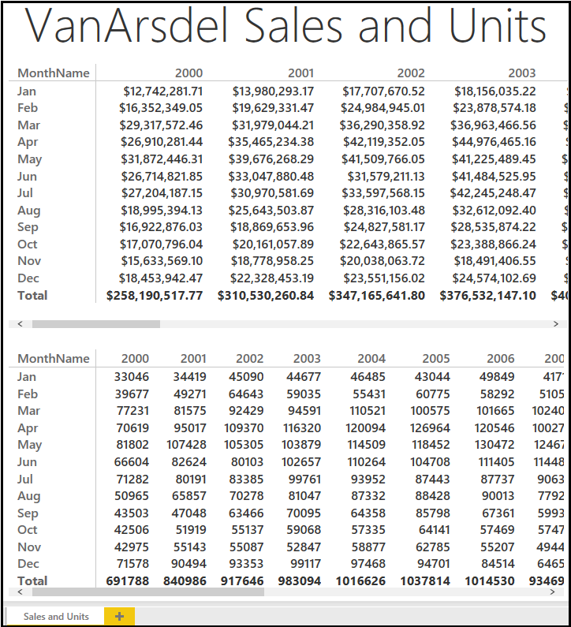

### **Lab Questions**

Answer the following questions using the report you created. (Do NOT include currency symbols or thousands separators). Do not use any level of filtering to answer the questions.

1. What is VanArsdel's sales for December 2013? (to two decimal places) 
2. What is VanArsdel's total units for the March 2013? 

## Exercise 2: Part-to-Whole Report

Now that you have the big picture, let's start analyzing the data sales data by product category, segment and manufacturer.

1. Create a new report page by clicking the Yellow "+" icon at the bottom of the report view.
2. Drag the **Total Sales** field from the **Sales** table to the report and create a chart.
3. Drag the **Category** and **Segment** fields from the **Products** table to the chart.
4. Modify the chart to use the **100% Stacked Bar Chart** visualization.
5. Ensure that the **Category** is shown as the **Axis** and the **Segment** is shown as the **Legend** of the visualization.
6. Customize the format of the visualization and turn on the **Data Labels**. Set the **Decimal Places** to **0**.
7. Drag the **Total Sales** field from the **Sales** table to the report and create a chart.
8. Drag the **Manufacturer** field from the **Manufacturers** table to the chart.
9. Modify the chart to use the **Treemap**visualization.
10. Drag the **MonthName** field from the **Date** table to the report and create a chart.
11. Modify the chart to use the **Slicer**visualization.
12. Drag the **Year** field from the **Date** table to the report and create a chart.
13. Modify the chart to use the **Slicer**visualization.
14. Rename the report sheet to **Sales Breakdown.**

**You should have something similar to the below:**

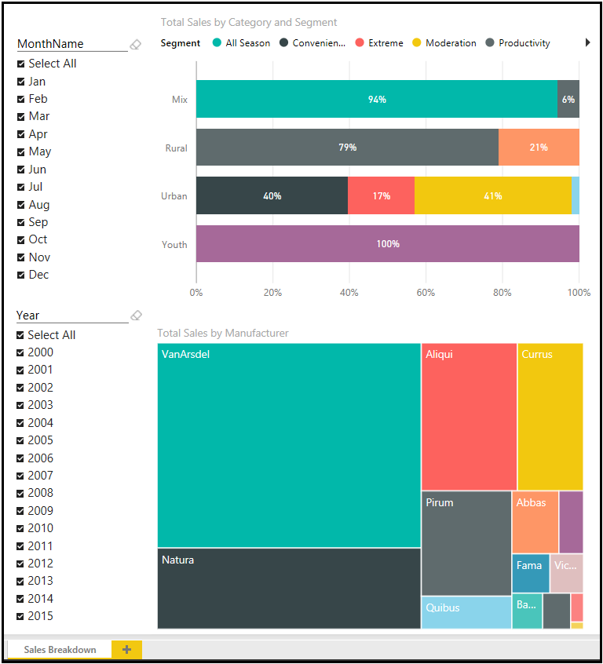

### **Lab Questions**

Answer the following questions using the report you created. (Do NOT include currency symbols or thousands separators). Do not use any level of filtering to answer the questions.

1. In January 2014, what is VanArsdel's sales, from all manufacturers, for Urban category and Moderation segment? (to two decimal places) (Hint: Try hovering on the chart)



1. In May 2015, what is VanArsdel's sales, from all manufacturers, for Mix category and All Season segment? (to two decimal places) (Hint: Try hovering on the chart)



1. Answer the following question by using the treemap chart you created.

For VanArsdel's sales in 2015, which are the top 4 manufacturers?

1 -

2 -

3 -

4 -

* Abbas
* Barba
* VanArsdel
* Currus
* Fama
* Leo
* Natura
* Pomum
* Pirum
* Quibus
* Salvus
* Victoria
* Aliqui

## Exercise 3: Relationship Report

You would like to know more about the relationship between total units and total sales by category and segment. You choose to analyze this using scatter chart.

1. Create a new report page by clicking the Yellow "+" icon at the bottom of the report view.
2. Create a chart based on the **Scatter Chart** visualization.
3. Drag the **Total Sales** and **Total Units** fields from the **Sales** table to the chart.
4. Drag the **Category**and **Segment** fields from the **Products** table to the chart.
5. Drag the **YTD Sales** field from the **Sales** table to the chart.
6. Drag the **Year**field from the **Date**table to the chart.
7. Ensure that the following fields are set in the visualization:
   * **Details**: Category
   * **Legend**: Segment
   * **X Axis**: Total Sales
   * **Y Axis**: Total Units
   * **Size**: YTD Sales
   * **Play Axis**: Year

You should have something similar to the below:

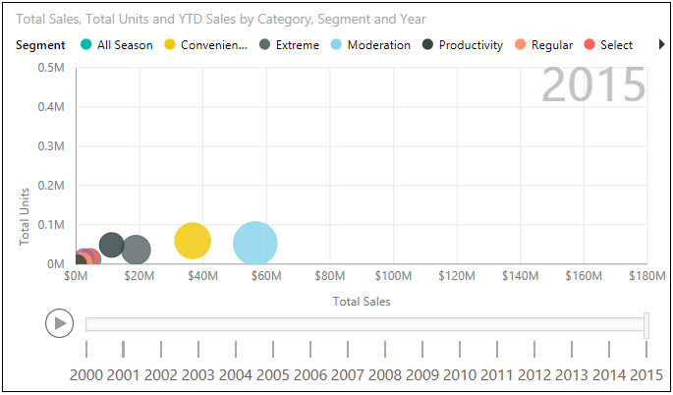

### **Lab Questions**

As you can see, in the year 2015, Moderation segment made the most of VanArsdel's sales. It is not always the case. Use the Play Axis to investigate.

1. In which year the Moderation segment first took over as the segment with most sales?                                                                                                                                         

1. What about in terms of Units? In which year the Moderation segment first took over as the segment with most units?



## Exercise 4: Trend Report

Let's do some trend analysis. First let's show a chart to compare Total Sales and Total Units throughout the years. And then let's show two more charts showing the Total Sales and Total Units variances throughout the years.

1. Create a new report page by clicking the Yellow "+" icon at the bottom of the report view.
2. Drag the **Year**field from the **Date**table to the report and create the first chart.
3. Drag the **Total Sales** and **Total Units** fields from the **Sales**table to the chart.
4. Modify the chart to use the **Line and Stacked Column Chart** visualization.
5. Ensure that the **Year**is shown as the **Shared Axis**, **Total** **Sales**is shown as the **Column values**, and **Total Units** is shown as the**Line values** of the visualization.
6. Create the second chart based on the **Waterfall Chart** visualization.
7. Drag the **Sales Var** field from the **Sales** table to the chart.
8. Drag the **Year**field from the **Date**table to the chart.
9. Create the third chart, also based on the**Waterfall Chart** visualization.
10. Drag the **Total Units Var** field from the **Sales** table to the chart.
11. Drag the **Year**field from the **Date**table to the chart.
12. Add a Text Box to the report and enter **Yearly Trend** as the text.
13. Rename the report sheet to**Yearly Trend.**

You should have something similar to the below:

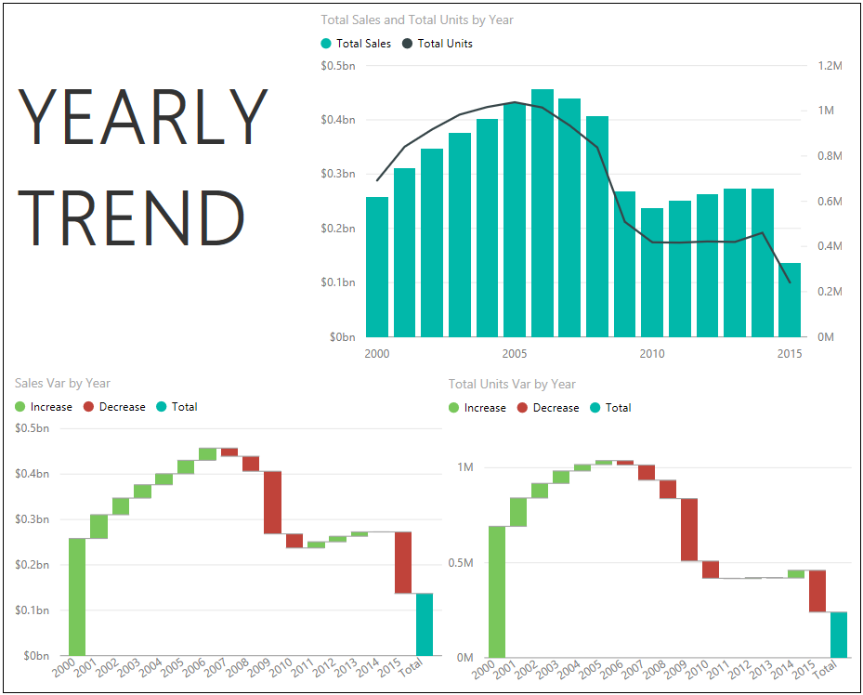

### **Lab Questions**

1. In which year the growth of total sales were not matched by the growth of total units?

2005

2006

2007

2008

1. Which year saw the biggest drop in total sales?

2007

2008

2009

2010

1. What about total units? Which year saw the biggest drop in total units?

2007

2008

2009

2010

## Exercise 5: Rank Report

You now want to analyze individual products sales (revenue) and volume (units). You decide to show these using two bar charts.

1. Create a new report page by clicking the Yellow "+" icon at the bottom of the report view.
2. Drag the **Total Sales** field from the **Sales** table to the report and create a chart.
3. Drag the **Product**field from the **Products** table to the chart.
4. Modify the chart to use the **Stacked Bar Chart** visualization.
5. Ensure that the chart is sorted by **Total Sales**.
6. Drag the **Total Units**field from the **Sales**table to the report and create a chart.
7. Drag the **Product**field from the **Products** table to the chart.
8. Modify the chart to use the **Stacked Bar Chart** visualization.
9. Ensure that the chart is sorted by **Total Units**.
10. Drag the **Year** field from the **Date** table to the report and create a chart.
11. Modify the chart to use the **Slicer**visualization.
12. Add a Text Box to the report and enter **Top Products**as the text.
13. Rename the report sheet to **Top Products.**

**You should have something similar to the below:**

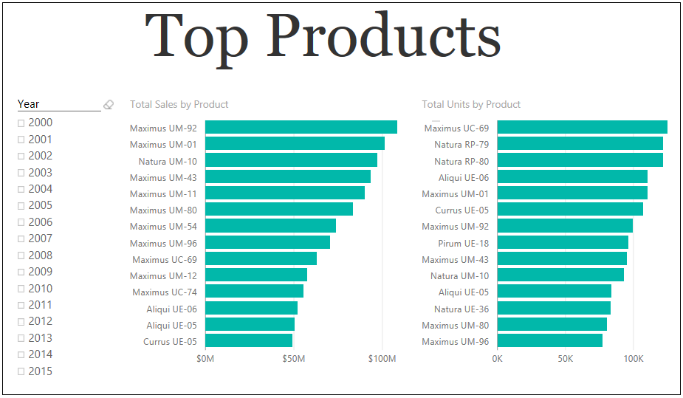

### **Lab Questions**

1. What is the top product in terms of sales for the year 2010?

Maximus UM-92

Maximus UM-43

Maximus UM-70

Maximus UM-11

Maximus UC-69

1. What about in terms of units? What is the top product in terms of total units for the year 2010?

Maximus UM-92

Maximus UM-43

Maximus UM-70

Maximus UM-11

Maximus UC-69